CD Lab #2
Question 1

// Program that takes a file as input and replaces blank spaces and tabs by single space and
// writes the output to a file

#include <stdio.h>
#include <stdlib.h>

int main(){
// declaring file pointers and variables
FILE *fa, *fa_, *fb;
int ca, ca_;

// opening files
fa = fopen("q1_src.c", "r");
fa_ = fopen("q1_src.c", "r");
fb = fopen("q1_res.c", "w+");

// checking if file oprns
if (fa == NULL){
printf("Cannot open file \n");
exit(0);
}

// going to first position of the file
ca = getc(fa);

// going to the second position of the file
ca_ = getc(fa_);
ca_ = getc(fa_);

// going through the document
while(ca != EOF){
if(ca == ' ' && ca_ == ' '){ // if more than 2 consecutive blanks are found
ca = getc(fa);
ca_ = getc(fa_);
continue;
} else if (ca == '\t' && ca_ == '\t') { // if more than 2 consecutive tabs are found
ca = getc(fa);
ca_ = getc(fa_);
continue;
} else if (ca == '\t' && ca_ != '\t') { // condensing consecutive tabs
putc(' ', fb);
ca = getc(fa);
ca_ = getc(fa_);
} else { // writing all other characters into the file
putc(ca, fb);
ca = getc(fa);
ca_ = getc(fa_);
}
}

// closing files
fclose(fa);
fclose(fa_);
fclose(fb);
return 0;
}

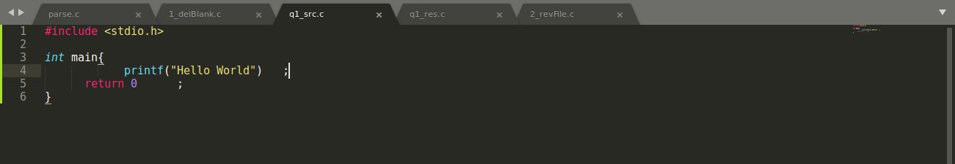
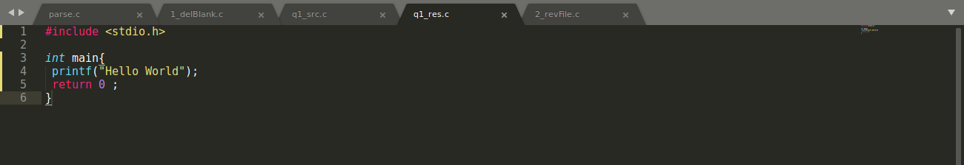

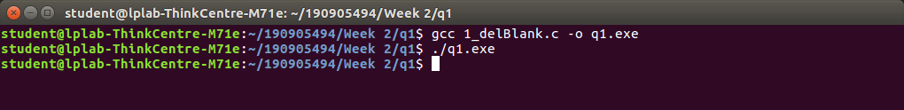

Question 2

// Program to discard preprocessor directives from the given input ‘C’ file.

#include <stdio.h>
#include <stdlib.h>

int main(){
// declaring file pointers and variables
FILE *fa, *fa_, *fb;
int ca, ca_, flag_1 = 0, flag_2 = 0;

// opening files
fa = fopen("q2_src.c", "r");
fa_ = fopen("q2_src.c", "r");
fb = fopen("q2_res.c", "w+");

// checking if file oprns
if (fa == NULL){
printf("Cannot open file \n");
exit(0);
}

// initializing ca
ca = getc(fa);

// initializing ca_
ca_ = getc(fa_);

// going through the document
while(ca != EOF){

// check if '#' is encountered
if(ca == '#'){

// check if it is actually a directive
while(ca_ != '\n'){
if(ca_ == '<') flag_1 = 1;
if(ca_ == '>') flag_2 = 1;
ca_ = getc(fa_);
}

ca_ = getc(fa_);

if(flag_1==1 && flag_2==1){ // removing directive
flag_2 = 0;
flag_1 = 0;

while(ca != '\n'){
ca = getc(fa);
}

ca = getc(fa);
continue;
} else { // keeping sentence with #
flag_2 = 0;
flag_1 = 0;

while(ca != '\n'){
putc(ca, fb);
ca = getc(fa);
}

putc(ca, fb);
ca = getc(fa);
continue;
}
}

// keeping all other charaters
putc(ca, fb);
ca = getc(fa);
ca_ = getc(fa_);
}

// closing files
fclose(fa);
fclose(fa_);
fclose(fb);
return 0;
}

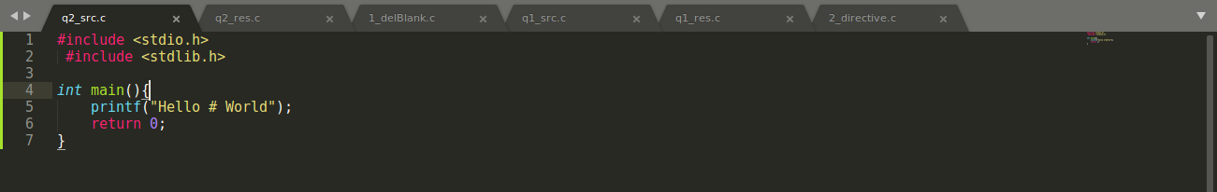

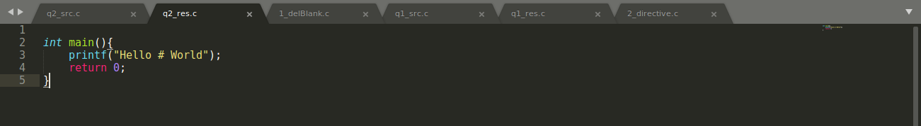

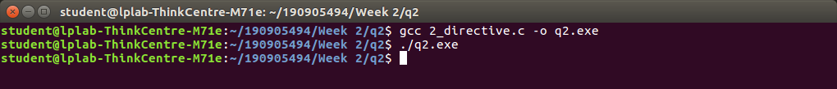

Question 3

// Program That takes C program as input, recognizes all the keywords and prints them in
// upper case.

#include <stdio.h>
#include <stdlib.h>
#include <string.h>
#include <ctype.h>

int main(){

// declaring file pointers and variables
FILE *fa;
int ca, i=0, j, k;
char buffer[100], ch, keywords[10][100] = {"int", "main", "if", "while", "do", "FILE", "char", "float", "continue", "break"};

// opening files
fa = fopen("q3.c", "r");

// checking if file oprns
if (fa == NULL){
printf("Cannot open file \n");
exit(0);
}

// initializing ca
ca = getc(fa);

printf("=== Keyword Found in the Document ===\n");

// going through the document
while(ca != EOF){

// skipping non alphanumeric
if(isalpha(ca) == 0) {
i=0;
ca = getc(fa);
continue;
}

// creating word
while(isalpha(ca) != 0){
buffer[i++] = ca;
ca = getc(fa);
}

// adding null char to end
buffer[i] = '\0';

// matching and printing buffer
for(j = 0; j<10; j++){
if(strcmp(buffer, keywords[j]) == 0){
for(k = 0; buffer[k] != '\0'; k++){
printf("%c", toupper(ch));
}
printf("\n");
}
}
}

// closing files
fclose(fa);
return 0;
}

